

Marmara University
Faculty of Engineering
PHYS 1103.4
PHYSICS LABORATORY-2024 FALL

EXPERIMENT 2
CONSTANT VELOCİTY and ACCELERATİON

Section Number: 17
Group Number: 5
Submitted to: Arş. Göv. Hüseyin YALTIRIK
Due Date: 15.11.2024
 | Dept | Student ID | Name Surname | Contribution
1 | Computer Engineering | 150123046 | Cihangir Yaman | Conclusion,Results,Upload Report
2 | Computer Engineering | 150123072 | Furkan Enes Sarıoğlu | Conclusion,Results, Theory,  Upload Report
3 | Computer Engineering | 150123005 | Yiğit | Conclusion,Result, Theory
1. Table of Contents

1. Purpose 2
2. Theory 2
3. Calculations 5
4.Conclusion ....8
5. References ..11
6. Appendix………………………………………………………………………………….12

Table of Figures
- Figure 1: Setup for experiment of constant velocity
- Figure 2: Setup for experiment of constant acceleration

Table of Figures
- Graph 1: Position – Time graph of each run
- Graph 2: Velocities of each run

Table of Tables
- Table 1: Average velocities of each run
- Table 2: Acceleration values of different inclination angles

1. Purpose
In this experiment, the aim is to compare theoretical predictions and results of the experiment of objects which have constant velocity or acceleration. The experiment is repeated by changing the slope of the ground to see how it affects the acceleration.

2. Theory

A List of Materials
1) Vernier Labquest Mini
2) Motion Detector
3) Moving Object
4) Ruler
Two separate experiments will be conducted. First one will be constant velocity experiment and second one will be constant acceleration.

The constant velocity experiment is conducted to demonstrate that an object moves equal distances in equal amounts of time. To satisfy the conditions of constant velocity experiment, the ground must be a straight line. That’s why, the ground’s angle must be 0. The ground’s angle should be measured by using protractor.

$$v=\frac{Δx}{Δt}$$
( v ): (velocity)
(Delta x): Change in position (final position - initial position)
( Delta t ): Time interval (final time - initial time)

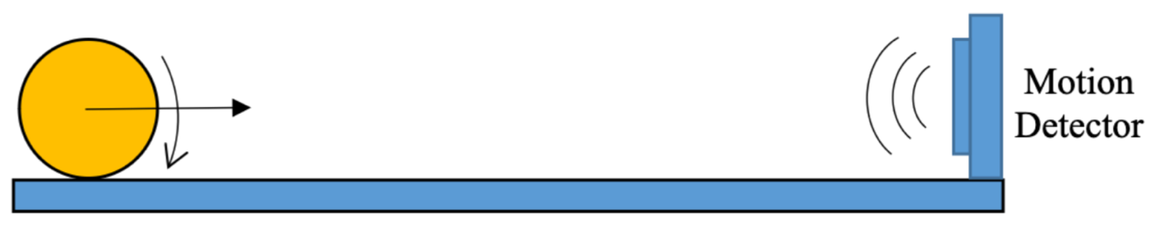
- Figure 1: Setup for experiment of constant velocity

Acceleration is defined as the change of the velocity at a particular time. Constant acceleration is the equal change of the velocity at equal times. To demonstrate different acceleration values, the angle of the ground is increased or decreased. Each experiment is repeated 5 times to ensure its precision.
( a ): Acceleration
( \Delta v ): Change in velocity (final velocity - initial velocity)
( Delta t ): Time interval (final time - initial time)
$$a=\frac{Δv}{Δt}$$

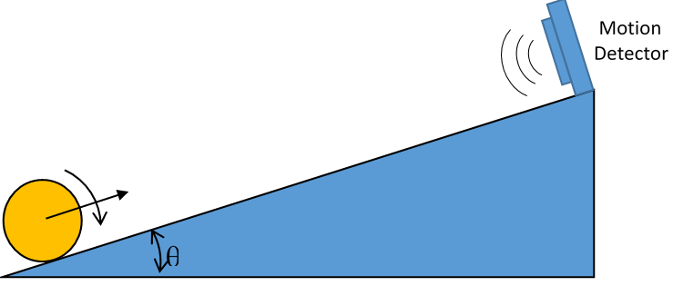
2. Figure 2: Setup for experiment of constant acceleration

3. Calculations

Part 1
Figure 1 : Setup for experiment of constant velocity

Table 1: Average velocities of each run
Run | Average Velocity
1 | 0.242
2 | 0.221
3 | 0.242
4 | 0.417
5 | 0.754

Related Equations:

v = Δx / Δt

theoretical result – experimental result = margin of error

error percentage = | margin of error – experimental result | * 100

Calculations:

Δx = 0.559 – 0.192 = 0.367
Δt = 2.50 – 1.05 = 1.45
0.367 / 1.45 = 0.253
0.253 – 0.242 = 0.011 margin of error
Error percentage = |0.011 / 0.242| * 100 = 4.5%

Δx = 0.619 – 0.191 = 0.428
Δt = 3 – 1.10 = 1.9
0.428 / 1.9 = 0.197
0.197 – 0.221 = -0.024 margin of error
Error percentage = |0.024 / 0.221| * 100 = 10.8%

Δx = 0.623 – 0.189 = 0.434
Δt = 2.25 – 0.50 = 1.75
0.434 / 1.75 = 0.248
0.248 – 0.242 = 0.006 margin of error
Error percentage = |0.006 / 0.242| * 100 = 2.4%

Δx = 0.626 – 196 = 0.430
Δt = 1.60 – 0.60 = 1
0.430 / 1 = 0.430
0.430 – 0.417 = 0.013 margin of error
Error percentage = |0.013 / 0.417| * 100 = 3.1%

Δx = 0.639 – 0.209 = 0.430
Δt = 1 – 0.45 = 0.55
0.430 / 0.55 = 0.781
0.781 – 0.754 = 0.027 margin of error
Error percentage = |0.027 / 0.754 | * 100 = 3.5%

Graphs :
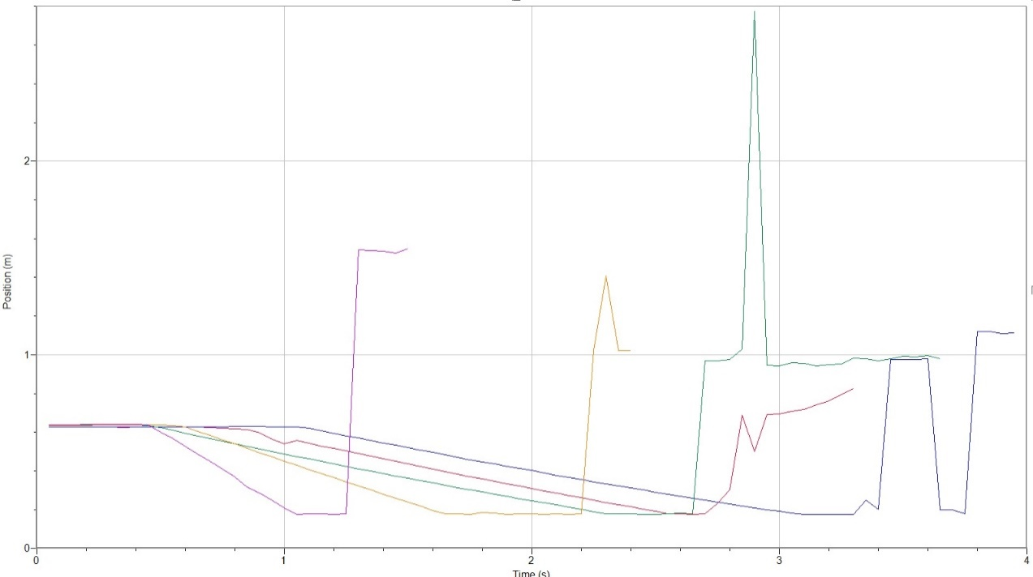
Graph 1 : Position – Time graph of each run
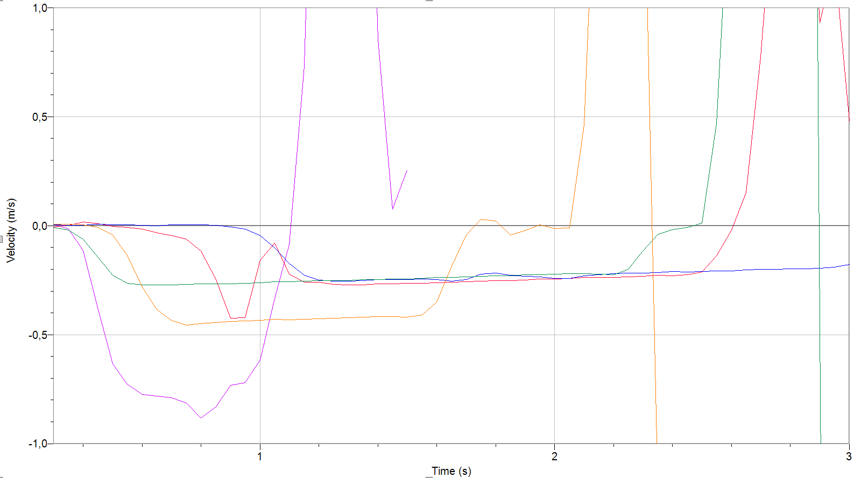
Graph 2: Velocities of each run

Part 2
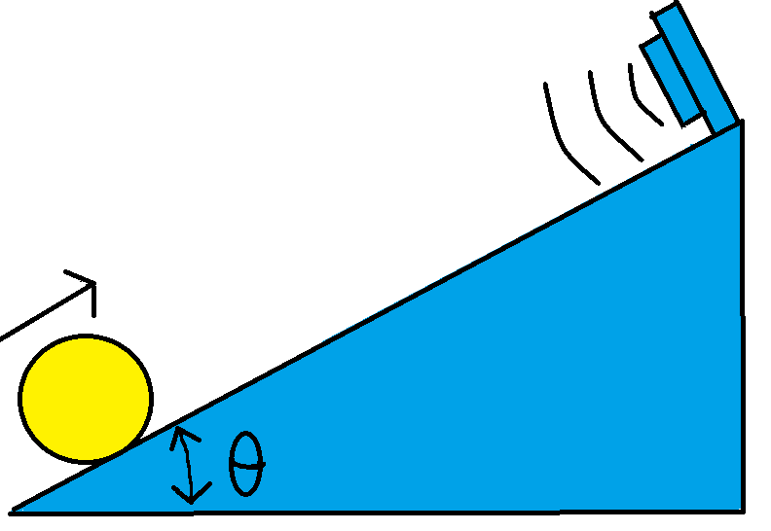
Figure 2: Setup for experiment of constant acceleration
Table 2: Acceleration values of different inclination angles
Run | θ₁=10º ±0.5 | θ₂=8.2º ±0.5 | θ₃=4.4º ±0.5
1 | 1.024 | 0.794 | 0.586
2 | 0.977 | 0.802 | 0.590
3 | 0.999 | 0.791 | 0.595
4 | 0.998 | 0.810 | 0.593
5 | 1.010 | 0.791 | 0.573

4. Conclusion

In this experiment, we throw objects to motion detector and measured constant velocity and constant acceleration. Then, we did theoretical calculations and we compared theoretical results and experimental results. According to the comparison, we calculate margin of error.

5. References
- Physics 1103.4 2nd Lab Manual
- https://canvas.instructure.com/files/275439797/download?download_frd=1

- University Physics with Modern Physics, Hugh D. Young, Roger A. Freedman, 15th Edition, Pearson, 2019.

6.Appendix

